Deckchairs:

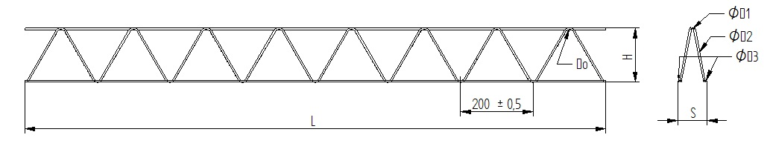

Height: 50-160mm (wires 4-3-3)

Height: 180-200mm (wires 4-3,5-3)

Lenght: 2m

|  |  |  |  |  |  |  |  |
| --- | --- | --- | --- | --- | --- | --- | --- |
| H (mm) | ØD1; ØD2; ØD3 | | | Weight (m) | Width  (mm) | Pcs in bundle | On Pallete |
| 50 | 4 | 3 | 3 | 0,3440 | 40 | 50 | 4000m |
| 60 | 4 | 3 | 3 | 0,3550 | 60 | 50 | 2800m |
| 80 | 4 | 3 | 3 | 0,3630 | 60 | 50 | 2400m |
| 100 | 4 | 3 | 3 | 0,3780 | 80 | 50 | 2400m |
| 120 | 4 | 3 | 3 | 0,3950 | 80 | 50 | 2000m |
| 140 | 4 | 3 | 3 | 0,4130 | 80 | 50 | 2000m |
| 160 | 4 | 3 | 3 | 0,4330 | 80 | 50 | 2000m |
| 180 | 4 | 3,5 | 3 | 0,5400 | 80 | 50 | 1600m |
| 200 | 4 | 3,5 | 3 | 0,5670 | 80 | 50 | 1600m |

Deckchairs:



Height 100-260mm (wires 6-4-5)

Lenght: 2m

|  |  |  |  |  |  |  |  |
| --- | --- | --- | --- | --- | --- | --- | --- |
| H (mm) | ØD1; ØD2; ØD3 | | | Weight (m) | Width  (mm) | Pcs in bundle | On Pallete |
| 100 | 6 | 4 | 5 | 0,8290 | 80 | 100 | 1800m |
| 120 | 6 | 4 | 5 | 0,8580 | 80 | 100 | 1800m |
| 140 | 6 | 4 | 5 | 0,890 | 80 | 100 | 1800m |
| 160 | 6 | 4 | 5 | 0,9260 | 80 | 100 | 1800m |
| 180 | 6 | 4 | 5 | 0,9600 | 80 | 100 | 1800m |
| 200 | 6 | 4 | 5 | 0,9950 | 80 | 100 | 1800m |
| 220 | 6 | 4 | 5 | 1,0310 | 80 | 50 | 900m |
| 240 | 6 | 4 | 5 | 1,0670 | 80 | 50 | 900m |
| 260 | 6 | 4 | 5 | 1,1030 | 80 | 50 | 900m |